Word-level analysis of the impact casued by COVID-19 on Mental Health

Rohit Raj
Computer Science Engineering Dept.
Chandigarh University
Mohali, Punjab, India
raj25480@gmail.com
Simran Priya
Computer Science Engineering Dept.
Chandigarh University
Mohali, Punjab, India
simran707@gmail.com
ABC
Computer Science Engineering Dept.
Chandigarh University

Abstract— Mental health issues span a variety of conditions that can influence a person's emotional state and behavior. Traditional methods for predicting mental illnesses are often hampered by challenges like over-detection, under-detection, and the lengthy manual process of reviewing patient data during screenings. This research seeks to integrate machine learning techniques to improve the prediction of mental health issues, providing support to conventional clinical assessments and diagnoses. The models explored in this project—Logistic Regression, K-Nearest Neighbors, and Random Forest—utilize key factors from a 2014 mental health survey dataset published by Open Source Mental Disorders to predict potential mental health concerns. By applying feature selection and fine-tuning hyperparameters, the study aims to identify significant contributors to mental health issues and optimize the models' performance. The models' effectiveness is assessed using metrics such as accuracy, recall, precision, F1 score, and AUROC. The experimental results reveal that the Random Forest model, enhanced through hyperparameters selected by RandomizedSearchCV, excels in cross-validation. This model demonstrates strong generalization on the test data, achieving an accuracy of 83.23%, recall of 89.87%, precision of 78.02%, F1 score of 83.53%, and an AUROC of 83.57%.
Keywords— COVID-19, mental health, anxiety, stress, depression

Introduction
Mental health disorders are conditions that can influence an individual's emotions and behaviors, leading to psychosocial impairments or a loss of functionality that necessitates treatment [1]. According to the World Health Organization, in 2019, 1 in 8 people out of a global population of 970 million were affected by a mental disorder [2]. In Malaysia, the National Health and Morbidity Survey conducted by the Ministry of Health revealed that one in three Malaysians experiences mental health challenges, with the highest prevalence observed among teenagers aged 16 to 19 and those from low-income households [3]. Many individuals suffering from mental illnesses such as anxiety, depression, post-traumatic stress disorder, and bipolar disorder often do not receive the necessary care, largely due to factors like a lack of awareness and barriers to accessing treatment [4]. Mental health issues can significantly disrupt a person's social interactions and daily life, potentially leading to decreased work performance. In severe cases, they may even result in self-harm or suicide [5]. It is important to note that diagnosing mental health conditions is a complex and nuanced process. Traditional approaches to predicting mental health problems involve a series of clinical evaluations, including face-to-face interviews between the patient and a healthcare professional. In this paper we have analysed the impact of COVID-19 pandemic on mental health of people questionnaires, and taking psychological tests. The process is prone to misdiagnosis, especially with a higher number of false positive cases [6]. Moreover, manually reviewing patient data for decision-making is ineffective and time-consuming, leading to a delay in early diagnosis in which early intervention can bring positive impacts on mental health.

BACKGROUND AND Related Work
Effective utilization of data within the healthcare sector plays a crucial role in identifying patterns of illnesses, enabling timely diagnoses, monitoring patients in real-time, and enhancing treatments [8]. The integration of Machine Learning is expected to lead to greater contributions and improved performance in these areas. To grasp the concept of Machine Learning, it's essential to understand that it is a subset of Artificial Intelligence, focused on using data and algorithms to mimic human learning processes, ultimately improving accuracy over time. Machine Learning can be categorized into four main types: supervised learning, unsupervised learning, reinforcement learning, and semi-supervised learning. Each category serves specific applications.
Supervised learning involves training a model on a labeled dataset to address classification tasks or predict future events. When the model encounters new, unlabeled data, it classifies or predicts based on the knowledge it gained during training. This method can be further divided into classification and regression tasks. Classification involves assigning new data to predefined categories, where each category is known as a label or target. The outcome of a classification task is a category (e.g., red or blue, spoon or fork, cat or dog), whereas regression tasks yield a numerical value. Supervised learning is particularly useful in applications like spam detection, speech recognition, cancer cell identification, and more.Unsupervised learning contrasts with supervised learning by requiring no human intervention. In this approach, the model is trained on unlabeled data to uncover hidden patterns without any human guidance. Unsupervised learning can be divided into clustering, association, and dimensionality reduction. Clustering focuses on grouping data points based on their similarities, which is often useful for organizing products that should be placed together. Association, on the other hand, uses rules to assess the dependency between different data points and is commonly applied to identify sets of products that customers frequently purchase together. Dimensionality reduction involves reducing the number of dimensions in a dataset while preserving its essential information. health of college students and requirement of proactive efforts to support the mental health and well-being of students are needed. Holmes et al. focuses on multidisciplinary mental health science research by exploring the psychological, social, and neuroscientific effects of COVID-19 [6]. The potential effects on individual and population mental health, and its probable effect on the brain function of several affected by the disease has been discussed. One more important aspect has been show-cased which deals with culture and self, independent and interdependent and freedom and determination of self [11]. The agenda of “stay at home stay safe” proved to be wrong in some scenarios; this is true evidently as in lockdown period some individuals are getting violated in different ways which is causing depression that in turn force you to take extreme steps [12]. Since beginning there have been many cases of neurological and neuropsychiatric instances in patients with COVID‐19. The complexities associated with the neuropsychiatric instance of COVID‐19 have led to estimates of the potential incidences of related disorders and patients admitted to the psychiatric ward with worsening psychiatric symptoms [13].

CATEGORIES
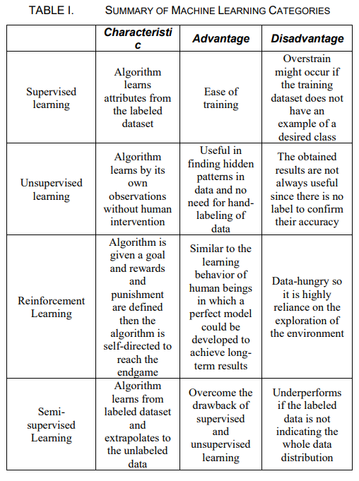
.

Results And Discussions

In this section, we have analyzed the country wise data for the keywords related to mental health during the COVID-19 pandemic. In the analysis various search terms are compared over time. A keyword analysis has also been implemented which compares each country’s trend rise along with comparison between Canada pre and post COVID-19.

Related-Work
The study in [9] analyzed data from the 2019 Open Source Mental Disorders (OSMI) mental health survey, which included responses from employees in both technology and non-technology sectors, to identify the seven most significant factors contributing to mental health issues out of 70 potential qualities. Various Machine Learning algorithms, including Support Vector Machine, K-Nearest Neighbors, Logistic Regression, Decision Tree, and Random Forest, were applied to these selected features. Among these, the Decision Tree algorithm demonstrated the highest accuracy and precision. The study also found that an individual's mental health history and family background were the most critical factors influencing their mental health.
In another study [10], the author examined eight methods—Decision Tree, Random Forest, Support Vector Machine, Naive Bayes, Logistic Regression, Extreme Gradient Boosting (XGB), Gradient Boost Machine, and Artificial Neural Network—to predict whether a person was suffering from depression. The evaluation metrics included sensitivity, specificity, precision, Negative Predictive Value (NPV), F1 Score, False Negative Rate (FNR), False Positive Rate (FPR), False Discovery Rate (FDR), False Omission Rate (FOR), and accuracy. The results indicated that Naive Bayes performed the worst, with the lowest accuracy of 21.67%, while Support Vector Machine achieved a high accuracy of 73.8%.
.

In [11], the author employed eleven different methods, including Logistic Regression, K-Nearest Neighbors, Decision Tree, Random Forest, Naive Bayes, Support Vector Machine, Adaptive Boost, SDG Classifier, Gradient Boosting, XGB, and Light Gradient Boosting, to investigate the external factors affecting employees' mental health using data from the OSMI mental health survey. Notably, Light Gradient Boosting is a gradient boosting technique based on Decision Trees, where data is split by leaves rather than tree depth, leading to higher accuracy and faster training times. The study found that the XGB model outperformed the other Machine Learning models in terms of overall accuracy, precision, recall, and F1 score.

:
In [12], the author applied several models, including Decision Tree, Support Vector Machine, Neural Network, Naive Bayes, and Logistic Regression, using SPSS Modeler to identify the factors contributing to mental health issues among students in higher education. The study aimed to classify individuals into categories such as stress, depression, and anxiety. The Decision Tree model outperformed the others in predicting stress. For anxiety prediction, Logistic Regression demonstrated the highest accuracy, specificity, and precision, though it exhibited an unexpectedly low sensitivity, nearly 20% lower than that of Neural Network, which had the best sensitivity performance. Support Vector Machine excelled in predicting depression, achieving an accuracy of 88.15%. The study concluded that factors such as lack of social support, financial challenges, and the learning environment significantly contribute to mental health issues.

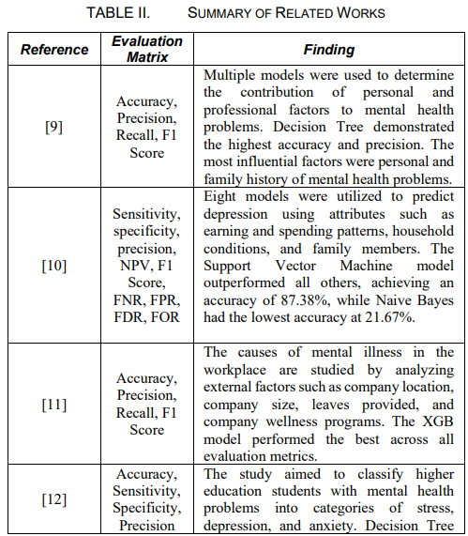

III. Machine Learning Techniques Used
As discussed in Section I, Machine Learning approaches are divided into supervised learning, unsupervised learning, reinforcement learning, and semi-supervised learning. Supervised learning is mainly applied for classification and predictive modeling using structured and labeled training datasets, whereas unsupervised learning deals with unstructured data without any supervision. In this study, only supervised learning algorithms were employed, as the dataset used contains labeled data.

A. Logistic Regression (LR)
Logistic Regression is based on the principle of creating a model to estimate the probability of a binary outcome or categorical value by analyzing the relationship between a dependent variable and one or more independent variables. The outcome value predicted by Logistic Regression ranges between 0 and 1, representing the probability of the result. This model uses the logistic function, also known as the sigmoid function, which is an S-shaped curve that transforms any real number into a value between 0 and 1. This transformation enables the prediction of the dependent variable’s class as a probability. The sigmoid function is mathematically expressed as:
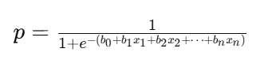

In this formula, ppp represents the probability of the dependent variable being in a specific class, eee denotes the base of natural logarithms, and b0,b1,b2,…,bnb_0, b_1, b_2, dots, b_nb0​,b1​,b2​,…,bn​ are the regression coefficients corresponding to the independent variables x1,x2,x3,…,xnx_1, x_2, x_3, \dots, x_nx1​,x2​,x3​,…,xn​.

B. K-NEAREST NEIGHOURS(KNN)
K-Nearest Neighbors (KNN) relies on the concept of proximity to predict or classify data points. As illustrated in Figure 2, KNN identifies the 'k' nearest training data points to a new data point and classifies or estimates the value of the new data point based on the majority class or average value of these nearest neighbors.
The K-Nearest Neighbors algorithm follows these steps:
- Set the value of 'k' to define the number of neighbors to consider.
- Use a distance metric to compute the distance between the new observation and the training data.
- Identify the 'k' closest training data points to the new observation.
- For classification, assign the new observation to the class that is most common among the 'k' nearest neighbors. For regression, predict the value based on the average of the 'k' nearest neighbors.
- Repeat the process for each new observation.

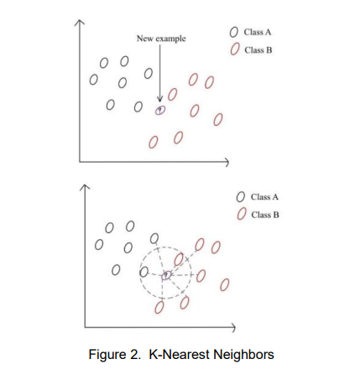

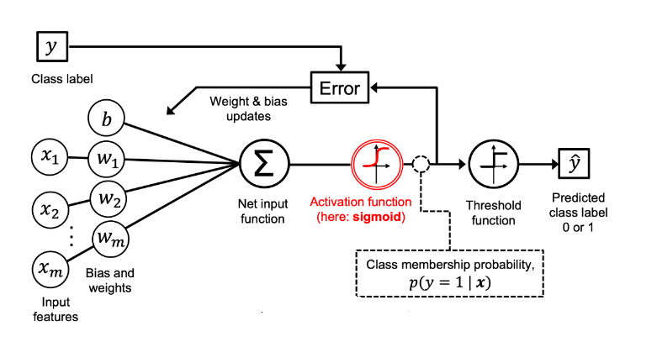

It is essential to understand that K-Nearest Neighbors
(KNN) is considered a lazy learning method, meaning
it does not build a predictive model from the training data
but instead keeps the entire training dataset in memory .
When classifying new data points, KNN uses a similarity
metric to compare the new point with the stored data.
Before classification, it is crucial to define the distance
metric. Custom distance metrics can be employed to
identify the nearest neighbors. A commonly used distance
metric is the Euclidean Distance, which measures the
straight-line distance between two points in
an n-dimensional space. This metric is particularly useful
when working with continuous variables in a multi-dimensional
It is also frequently applied in clustering tasks to group similar
data points based on their distances. The Euclidean Distance is
calculated by taking the square root of the sum of the squared
differences between corresponding coordinates of the two points,
and is represented as:

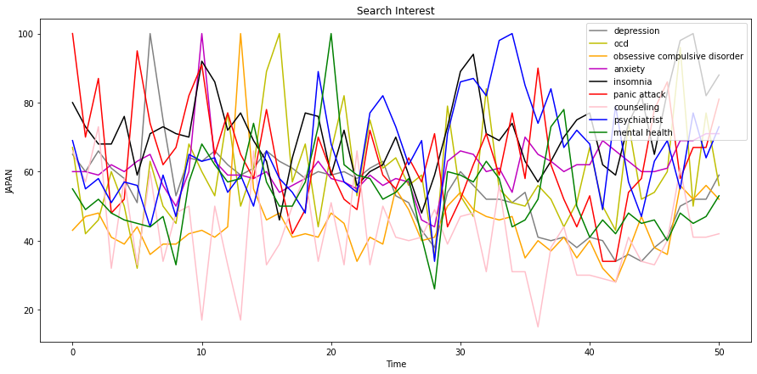
Fig. 5. Distribution of most searched words related to mental health during COVID-19 in Japan.
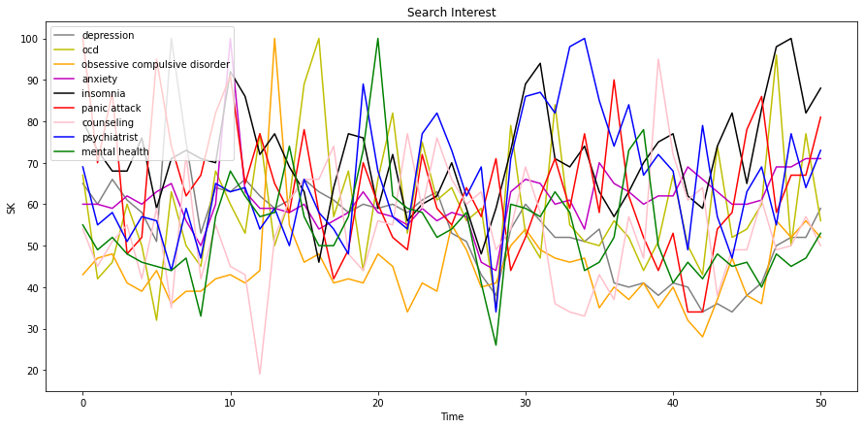
Fig. 6. Distribution of most searched words related to mental health during COVID-19 in South Korea.

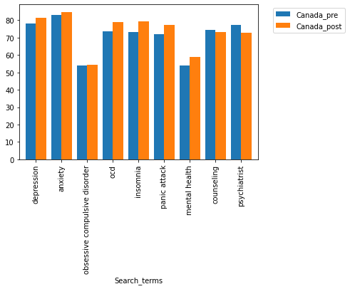
Fig. 7. Comparison of most searched words for pre and post COVID-19 era in Canada.

Conclusion

In this paper, we have discussed how the COVID-19 pandemic has affected the health of individuals. The adverse effect of pandemic can be observed by detecting an increased search for the words related to mental health. We examined the top mental health search terms and investigated their trend in various counties during this world-wide pandemic. These trends exhibited the mental crisis that dawned upon people across the globe over the course of 50 weeks.
Fig. 8 conveys how anxiety and depression took the top spots followed by insomnia which is closely associated to the

other two illnesses. The spikes in the graph portrays how different news or events caused a disrupt in the health of the general public.
The country wise analysis for each search term and the comparison between pre-COVID era and the post-COVID era has been presented. It can be clearly noticed that the people are suffering from various mental health issues like anxiety, stress, depression, insomnia, etc. This research demonstrates how people can not only be affected by fear of virus but also the cabin fear caused by it.
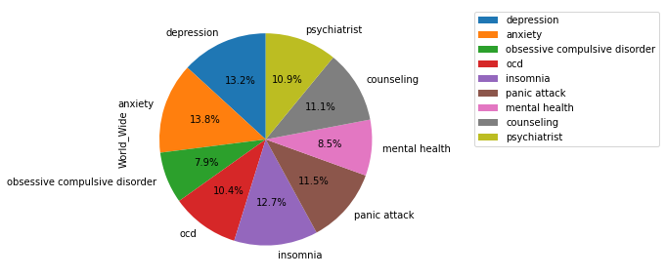
Fig.8 Distribution of most searched words related to mental health during COVID-19 in the world.

References

- RP. Rajkumar. "COVID-19 and mental health: A review of the existing literature." Asian journal of psychiatry 52 (2020): 102066.
- S.K. Schäfer, M. R. Sopp, C.G. Schanz, M. Staginnus, A.S. Göritz, and T. Michael. "Impact of COVID-19 on public mental health and the buffering effect of a sense of coherence." Psychotherapy and psychosomatics 89, no. 6 (2020): 386-392.
- EB. Mukaetova-Ladinska, G. Kronenberg, and R. Raha-Chowdhury. "COVID-19 and neurocognitive disorders." Current opinion in psychiatry 34, no. 2 (2021): 149.
- A. Roy, A. K. Singh, S. Mishra, A. Chinnadurai, A. Mitra, and O. Bakshi. "Mental health implications of COVID-19 pandemic and its response in India." The International journal of social psychiatry (2020).
- S. Das. "Mental Health and Psychosocial Aspects of COVID-19 in India: The Challenges and Responses." Journal of Health Management 22, no. 2 (2020): 197-205.
- EA. Holmes, R. C. O'Connor, V. H. Perry, I. Tracey, S. Wessely, Louise Arseneault, Clive Ballard et al. "Multidisciplinary research priorities for the COVID-19 pandemic: a call for action for mental health science." The Lancet Psychiatry (2020).
- C. Son, S. Hegde, A. Smith, X.Wang, and F. Sasangohar. "Effects of COVID-19 on college students’ mental health in the United States: Interview survey study." Journal of medical internet research 22, no. 9 (2020): e21279.
- A. Dawel, Y. Shou, M. Smithson, N. Cherbuin, M. Banfield, A.L. Calear, L.M. Farrer. "The effect of COVID-19 on mental health and wellbeing in a representative sample of Australian adults." Frontiers in psychiatry 11 (2020): 1026.
- A. Kecojevic, C.H. Basch, M. Sullivan, and N.K. Davi. "The impact of the COVID-19 epidemic on mental health of undergraduate students in New Jersey, cross-sectional study." PloS one 15, no. 9 (2020): e0239696.
- M. Pierce, H.Hope, T. Ford, S. Hatch, M. Hotopf, A. John, E. Kontopantelis. "Mental health before and during the COVID-19 pandemic: a longitudinal probability sample survey of the UK population." The Lancet Psychiatry 7, no. 10 (2020): 883-892.
- A. Scalabrini, J. Xu, and G. Northoff. "What COVID‐19 tells us about the self–the deep inter‐subjective and cultural layers of our brain." Psychiatry and clinical neurosciences (2020).
- A. Pattojoshi, A. Sidana, S. Garg, S. Narayan Mishra, L.K. Singh, N.Goyal, and S. K. Tikka. "Staying home is NOT ‘staying safe’: A rapid 8‐day online survey on spousal violence against women during the COVID‐19 lockdown in India." Psychiatry and clinical neurosciences (2020).
- A. Zandifar and R Badrfam. "Exacerbation of psychosis accompanied by seizure and catatonia in a patient with COVID‐19: A case report." Psychiatry and Clinical Neurosciences (2020).
- S. Vashishtha and S. Susan. "Sentiment Cognition from Words Shortlisted by Fuzzy Entropy." IEEE Transactions on Cognitive and Developmental Systems 12, no. 3 (2019): 541-550.
- S. Vashishtha and S. Susan. "Fuzzy Interpretation of Word Polarity Scores for Unsupervised Sentiment Analysis." In 2020 11th International Conference on Computing, Communication and Networking Technologies (ICCCNT), pp. 1-6. IEEE, 2020.
- S. Vashishtha and S. Susan. "Fuzzy logic based dynamic plotting of mood swings from tweets." In International Conference on Innovations in Bio-Inspired Computing and Applications, pp. 129-139. Springer, Cham, 2018.
- Accessed on 15th Mar2021, https://www.kaggle.com/luckybro/mental-health-search-term

